Continue setup (ubuntu 20.04)

Table of contents:

1. Install Tmux
   1. Overview
   2. Installation setup
2. Install emacs
   1. Overview
   2. Installation setup
3. Install Fail2Ban
   1. Overview
   2. Installation setup
4. Install cowsay
   1. Overview
   2. Installation setup
5. Install lolcat
   1. Overview
   2. Installation setup

1. Install Tmux
   1. Overview

Tmux is terminal multiplexer that we can use to open more than one terminal windows in one place and do so many tasks in one place.

* 1. Installation setup
* First, we check if we have the Tmux package in our local repository by typing the command blow:

Sudo apt search tmux

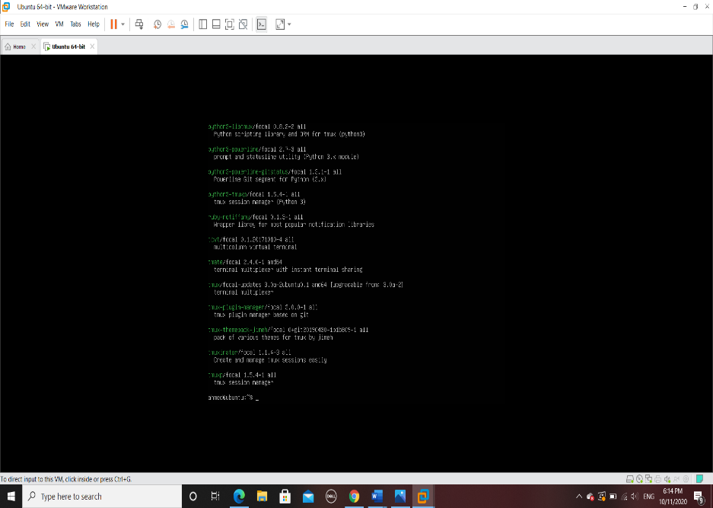

The Tumx package is available.

* Second start the installation by typing the command blow:

Sudo apt install tmux

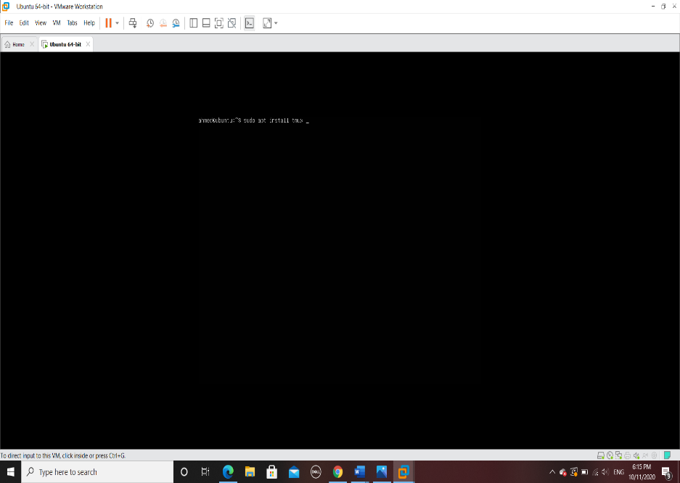

* After the installation is done we check the location of the installed file by typing the command blow:

Which tumx

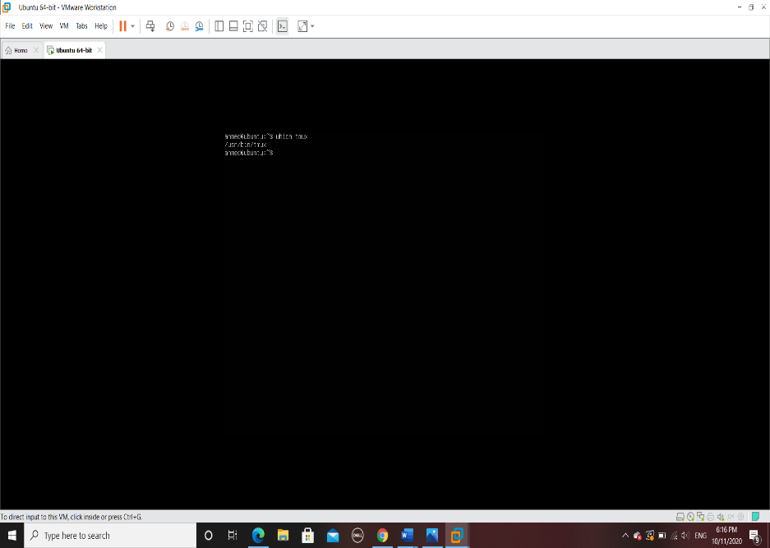

1. Install emacs
   1. Overview

Emacs is text editor that give so many powerful features to edit files, for example auto correct spelling mistakes and even given a different color to your text that’s why emacs is a best tool for programming.

* 1. Installation setup
* First, we check if we have the emacs package in our local repository by typing the command blow:

Sudo apt search emacs

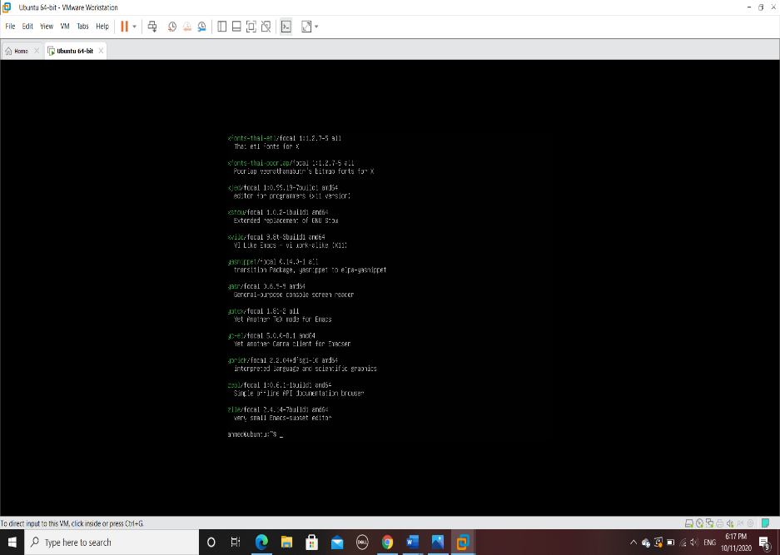

The emacs package is available.

* Second start the installation by typing the command blow:

Sudo apt install emacs

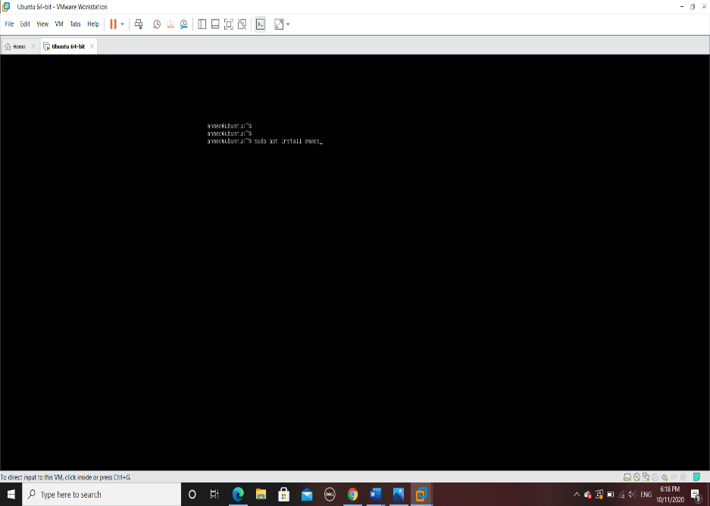

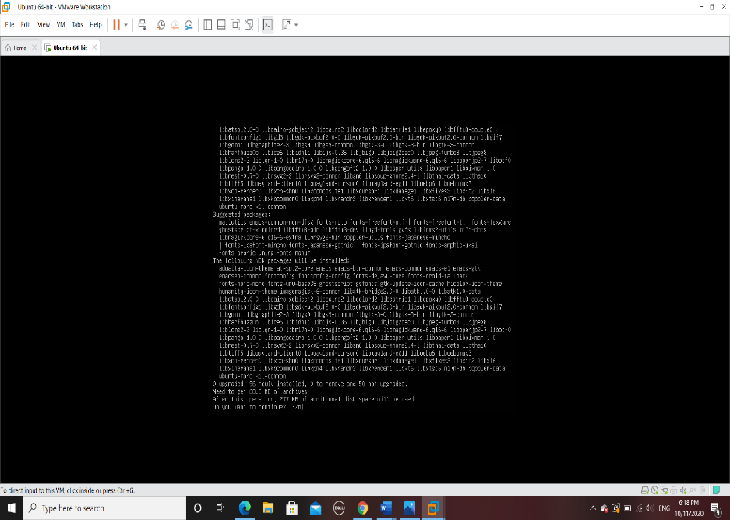

Here they give the summary of the package type yes to continue

* After the installation is done will check the location of the installed file by typing the command blow:

Which emacs

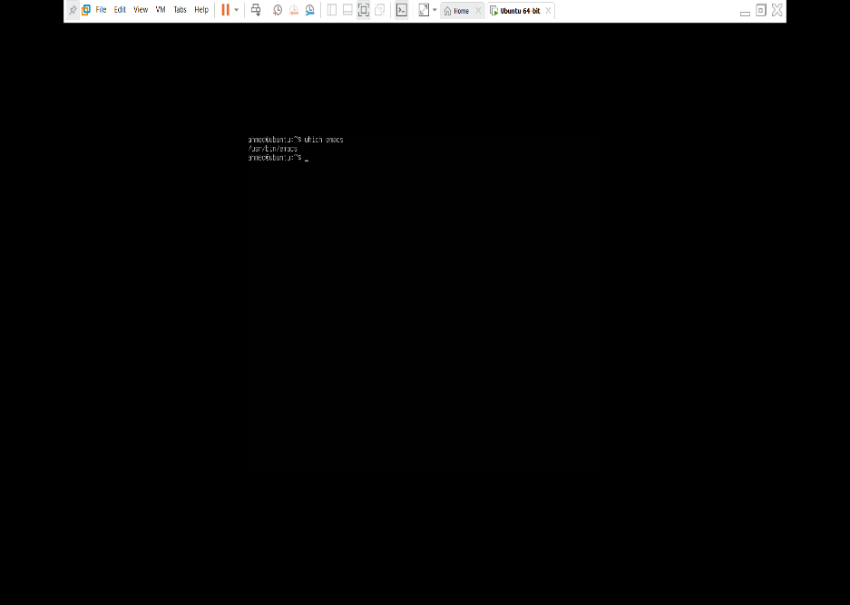

1. Install Fail2Ban
   1. Overview

Fail2Ban is used to controller and analyses the log in to your server given the protection against brute-force attacks.

* 1. installation setup
* First, we check if we have the Fail2Ban package in our local repository by typing the command blow:

Sudo apt search fail2ban

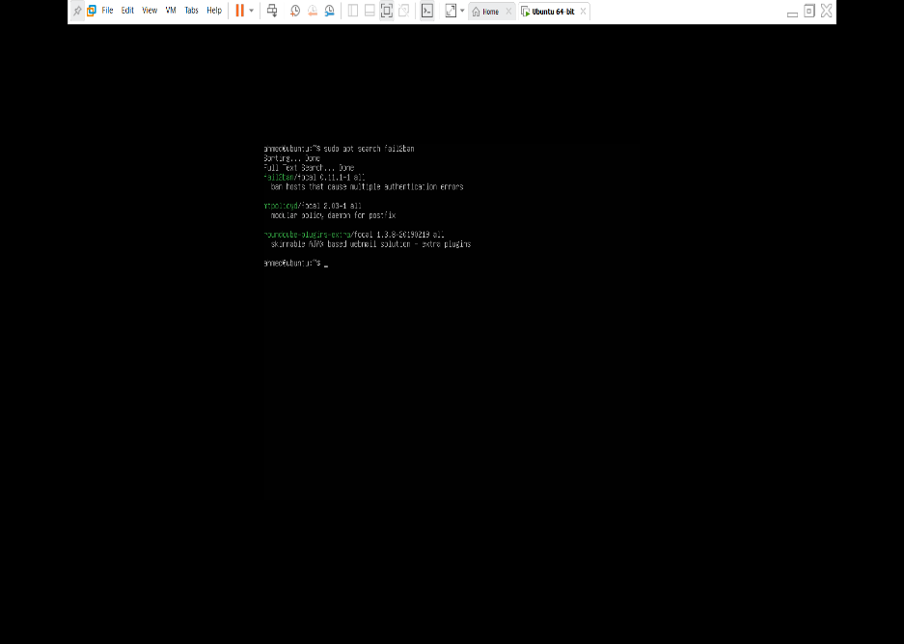

The fail2ban package is available.

* Now we can start the installation by typing the command blow:

Sudo yum install fail2ban

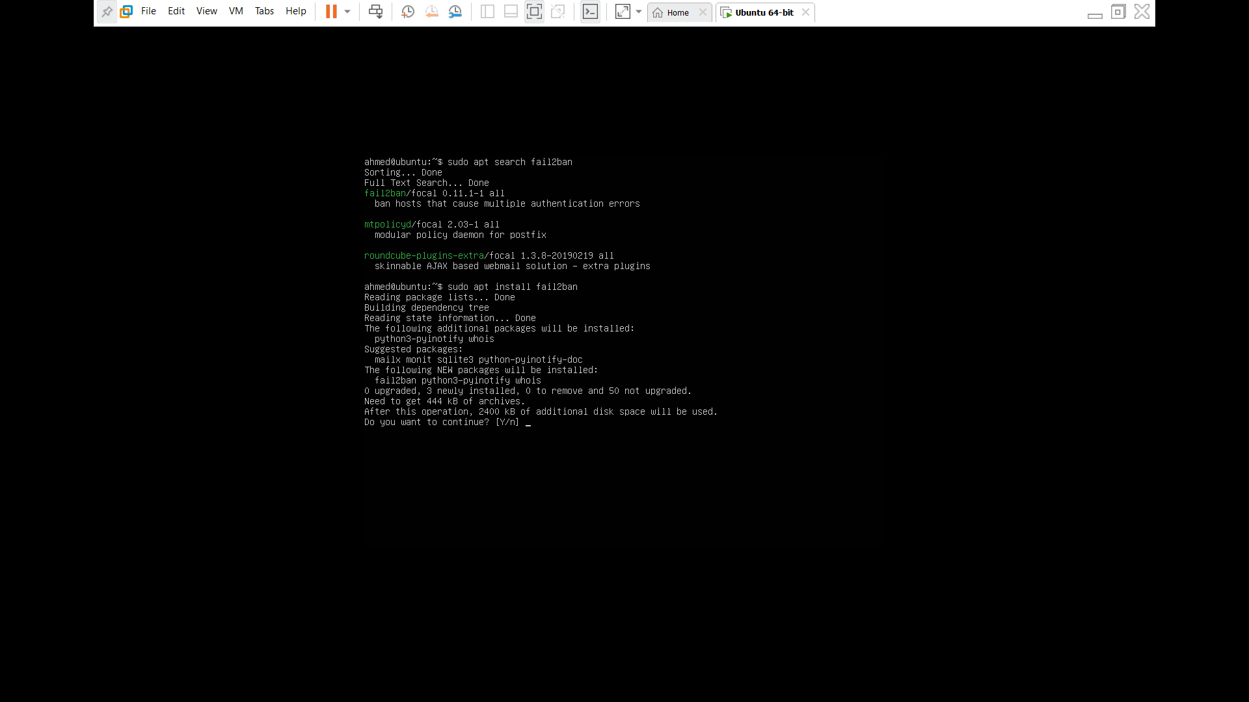

Here they give the summary of the package type yes to continue

1. Install cowsay
   1. Overview

Cowsay is program that display a image of animals like cow with a message.

* 1. Installation setup
* First, we check if we have the cowsay package in our local repository by typing the command blow:

Sudo apt search cowsay

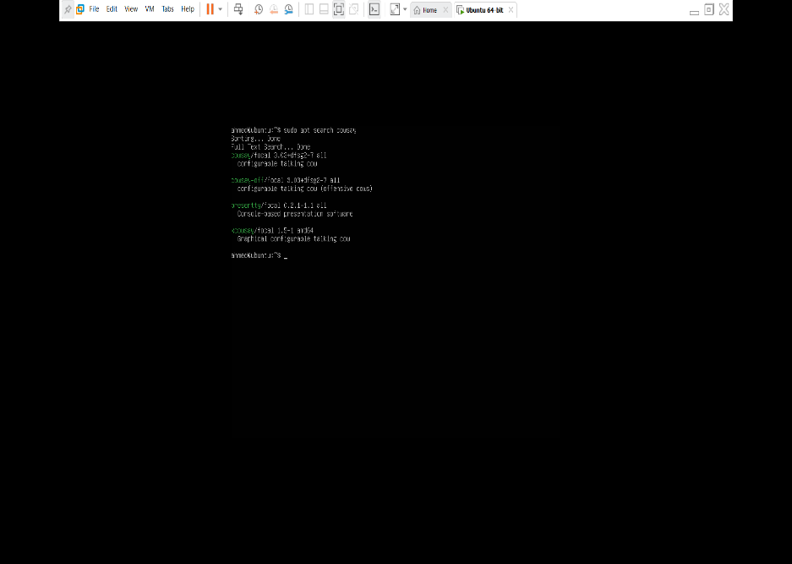

The emacs package is available.

* Second start the installation by typing the command blow:

Sudo apt install cowsay

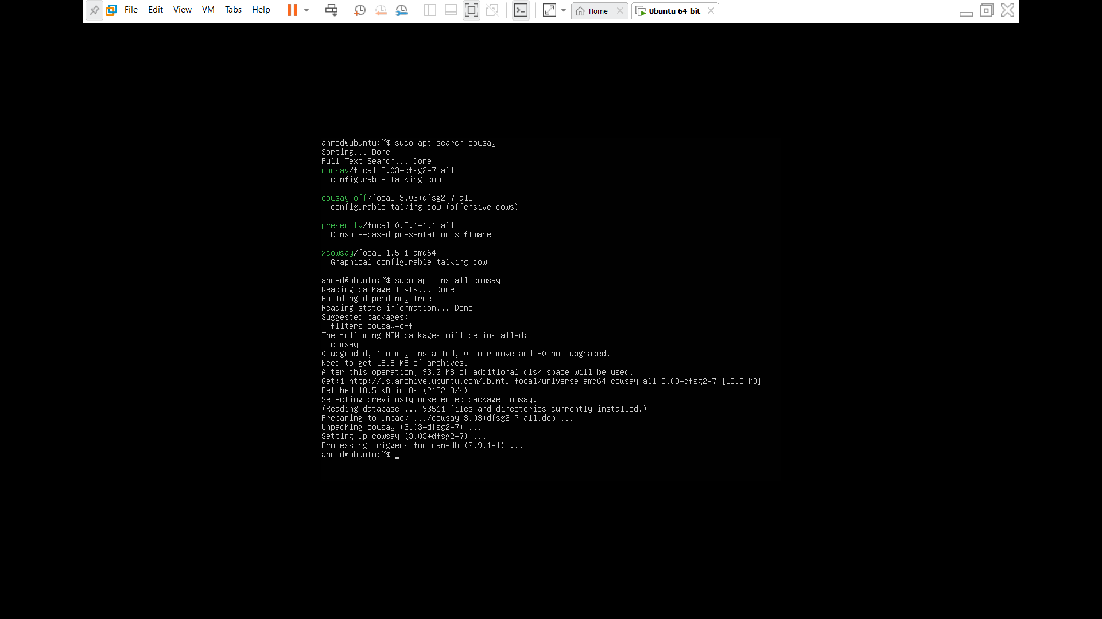

Here they give the summary of the package type yes to continue

* After the installation is done, we check the location of the installed file by typing the command blow:

Which cowsay

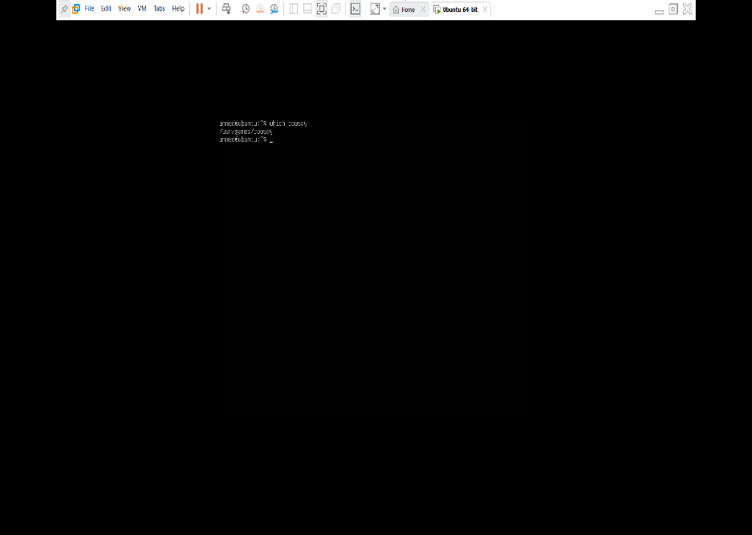

1. Install lolcat
   1. Overview

Lolcat is used to display any text file or output with rainbow color.

* 1. installation setup
* First, we check if we have the lolcat package in our local repository by typing the command blow:

Sudo apt search lolcat

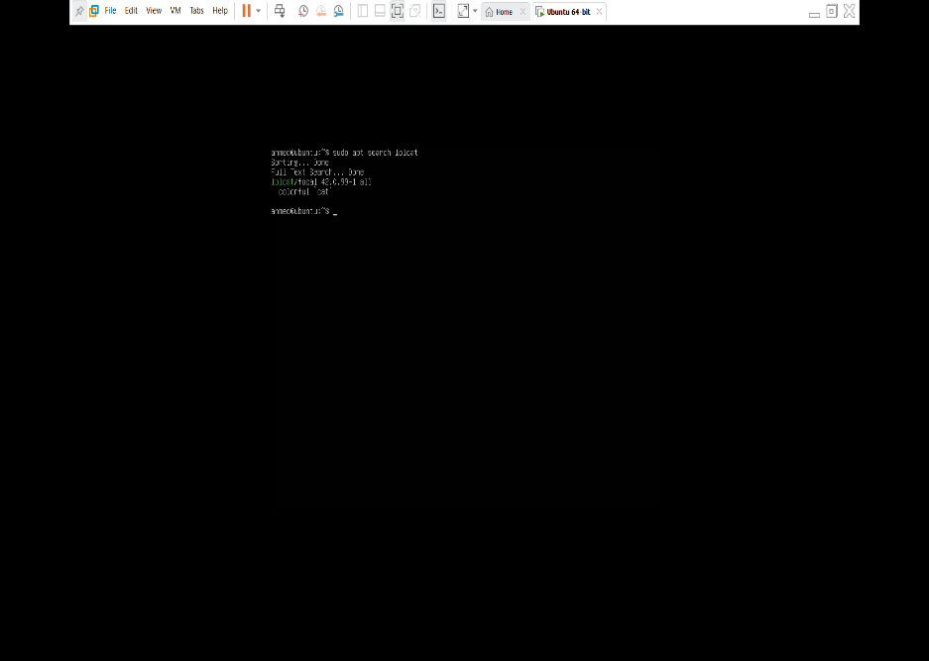

The lolcat package is available.

* Second start the installation by typing the command blow:

Sudo apt install lolcat

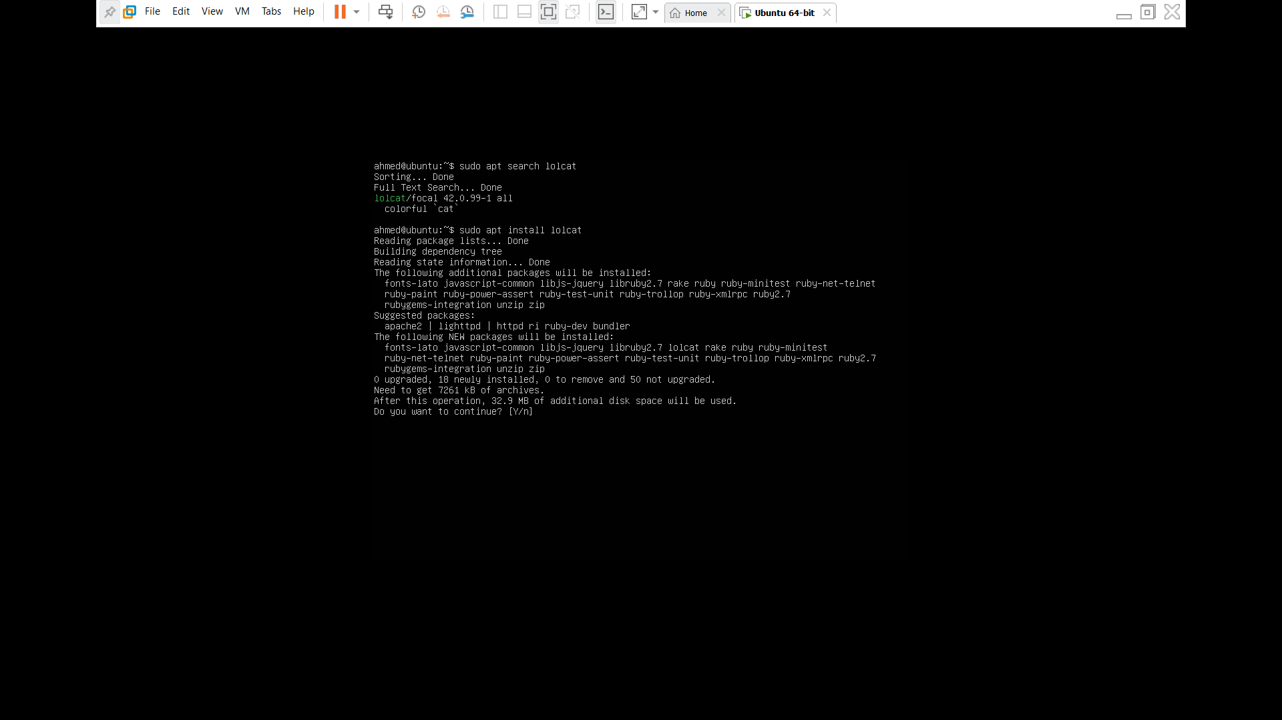

Here they give the summary of the package type yes to continue

* After the installation is done, we check the location of the installed file by typing the command blow:

Which cowsay

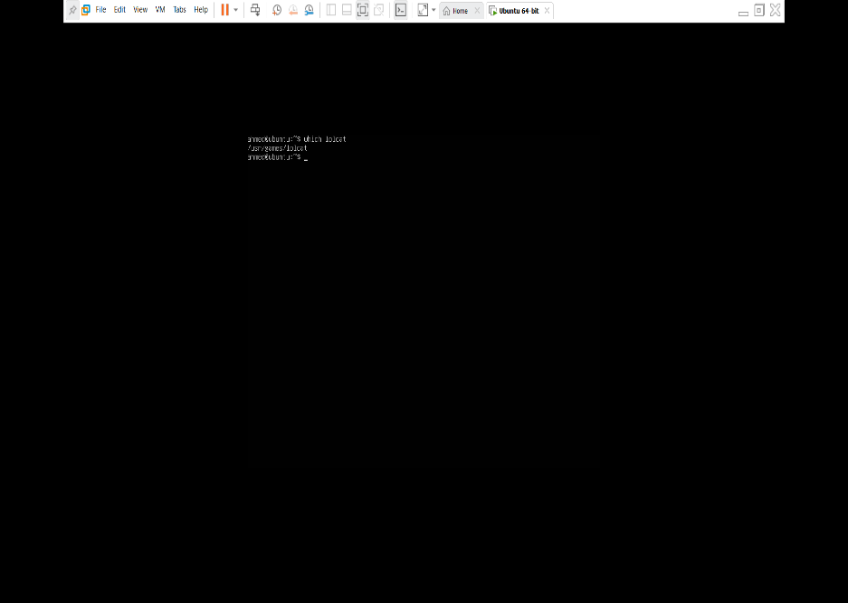

1. update vi to vim
   1. Overview

Vim is very known text editor in Linux environment, came with allot of approvement over vi for example flexible insert mode, visual mode, online help system, macros.

* 1. Installation setup
* Because my server is updating from my first assignment, my vim is in the newest version you can update your server by typing the command blow:

sudo apt-get update 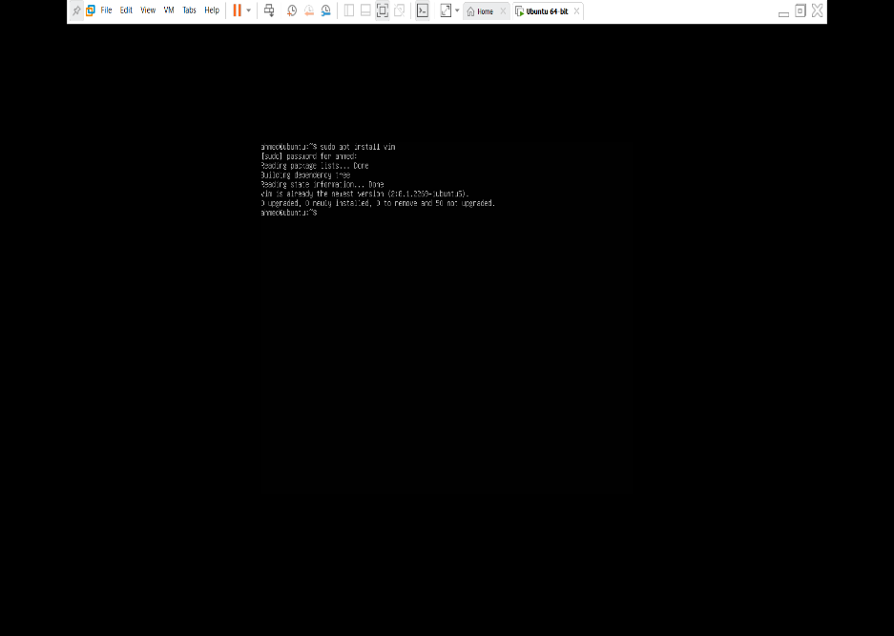

* After the installation is done, we check the location of the installed file by typing the command blow:

Which vim

